 HOSTE D BY

Available online at [www.sciencedirect.com](http://www.sciencedirect.com/science/journal/2314808X)

**ScienceDirect**

journal homepage: [http://ees.elsevier.com/ejbas/default.asp](http://http//ees.elsevier.com/ejbas/default.asp)

**Full Length Article**

**Ultrastructural studies on the nuclear elements in differentiating and degenerative ciliated olfactory neuron of *Pseudapocryptes lanceolatus* (Gobiidae: Oxudercinae)**



***S.K. Sarkar*** ***a******, T.C. Nag*** ***b******, S.K. De*** ***a******,******\****

a *Ultrastructure and Fish Biology Research Unit, Department of Zoology, Vidyasagar University, Midnapore* *(West), West Bengal 721 102, India*

b *Department of Anatomy, All India Institute of Medical Sciences (AIIMS), New Delhi 110029, India*

A R T I C L E I N F O A B S T R A C T

*Article history:*

Received 26 April 2015

Received in revised form 1 July 2015 Accepted 21 July 2015

Available online 31 July 2015

*Keywords:*

*P. lanceolatus* Olfactory Neurogenesis Sensory Chromatin

The cellular event of neurogenesis and neural degeneration of ciliated sensory receptor neuron within the adult olfactory neuroepithelial system has been studied in *Pseudapocryptes lanceolatus* (Bloch and Schneider, 1801) under light microscope (LM), fluorescence microscope and trans- mission electron microscope (TEM: Morgagni 268D) respectively. The unilamellar olfactory apparatuses of *P. lanceolatus* were dissected and fixed in 2.5% glutaraldehyde and 4% paraform- aldehyde in 0.1 M phosphate buffer (pH 7.2–7.4) at 4 °C for microscopical studies. The LM study indicates that the progenitor basal cell proliferates to form electron lucent basal cell which differentiates into ciliated sensory receptor neuron within the olfactory neuroepi- thelium. Investigation under fluorescence microscope using Acridine Orange revealed that the nuclear elements in differentiating stages of electron lucent basal cell, mature and de- generating sensory receptor cell show notable features of gradual condensation. TEM study indicates the subsequent condensation of chromatin granules (diameter ranging from 10 nm– 20 nm to 15 nm–30 nm) in various differentiating stages of electron lucent basal cell. The mature ciliated sensory receptor cell possesses chromatinized nucleus with large accumu- lation of chromatin granules (diameter: 20 nm–30 nm) at the peripheral nucleoplasm whereas degenerating sensory receptor cell possesses fragmented chromatin fibers. Therefore, these distinctive features of chromatin condensation are assumed to be a prime subcellular in- dicator of neural aging of olfactory sensory receptor cell.

© 2015 Mansoura University. Production and hosting by Elsevier B.V. This is an open

access article under the CC BY-NC-ND license (<http://creativecommons.org/licenses/by->

nc-nd/4.0/).

* *Corresponding author.* Tel.: +(91) 9432093473.

*E-mail address:* [skdvu@yahoo.co.in](mailto:skdvu@yahoo.co.in) (S.K. De). <http://dx.doi.org/10.1016/j.ejbas.2015.07.004>

2314-808X/© 2015 Mansoura University. Production and hosting by Elsevier B.V. This is an open access article under the CC BY-NC-ND license ([http://creativecommons.org/licenses/by-nc-nd/4.0/).](http://creativecommons.org/licenses/by-nc-nd/4.0/))

# Introduction

Olfaction is a primitive type of chemosensory modality that is involved in the detection and discrimination of various chemi- cal cues from the external environment through sensory receptor cells [1,2]. The ciliated sensory receptor cell (a bipolar neuron) is regarded as the primary neuron and predominantly found within the olfactory neuroepithelium [3].This type of cell is spe- cialized for the recognition of various chemical stimuli from the external environment and evolutionarily conserved across the vertebrate phyla [4–7]. The neurogenesis of olfactory sensory neuron in both postnatal development and adult stage is a very unique phenomenon in vertebrate olfactory neuroepithelium (including teleosts) [8]. The primary olfactory sensory receptor cell has a definite life span and successively shows neural apop- tosis at the end [9,10]. The basal cell may proliferate and differentiate into new primary sensory neurons within the ol- factory neuroepithelium [11,12].This cellular event is also regarded as cellular dynamics in adult olfactory neuroepithelium [13].A diagrammatic model of this cellular event was proposed by Sulz and Bacigalupo [14] but the subcellular organelle based cyto- logical details of neurogenesis, neural differentiation, neural degeneration, *etc.* are still not characterized. Recently, Armelin- Correa et al. [15] have described the subdivision of nucleus in lieu of gene expression of odorant receptors (OR) in olfactory sensory receptor cell. The structural changes in nuclear ele- ments are responsible for variable rate of transcription in various stages of differentiation during olfactory neurogenesis and neural degeneration [16,17]. Therefore, it would be more worthwhile to explore the cytological details as well as possible qualitative variation in nuclear elements within the various differentiat- ing stages of olfactory neurogenesis and neural degeneration. *Pseudapocryptes lanceolatus* (Bloch and Schneider, 1801) is a te- leostean: gobiid. This species possesses unilamellar olfactory apparatuses externally lined by olfactory neuroepithelium and populated with sensory receptor cell, supporting cell and basal cell [18–20]. The functional proliferation of basal cell within the olfactory neuroepithelium is evident in different age groups of

*P. lanceolatus* [21]. The present study is focused on the unex- plored fine structural characterization of nuclear elements at different stages of neural differentiation and degeneration within the adult olfactory neuroepithelium of *P. lanceolatus* to correlate the subcellular aspect of neurogenesis and neural degeneration.

# Materials and methods

*P. lanceolatus* is a common mudskipper of Gangetic Bengal.There are no known threats recorded in the IUCN Red List Category

*P. lanceolatus* (*i.e.,* ‘Least Concern’) [website: [http://www.iucnredlist](http://www.iucnredlist.org/details/169496/0)

[.org/details/169496/0](http://www.iucnredlist.org/details/169496/0)]. For electron microscopical study, the fresh, adult (having total body length of 150 mm to 200 mm) specimens of *P. lanceolatus* were directly collected from the clear stretches of Hooghly River at Barrackpore (North 24 Parganas,West Bengal, India, 22° 46 N, 88°20 E) and Tribeni (Hooghly, West Bengal, India, 22°59 N, 88°23 E) during the breeding season (*i.e.,* June 2012– August 2012); brought to the laboratory for acclimatization with

the physical conditions [temperature: 20 °C–25 °C, humidity: >40%, time: 24 hours, *etc.*]. The specimens were anesthetized by using MS – 222 (dose: 100 mg/L–200 mg/L) for microscopical studies. The olfactory apparatuses of *P. lanceolatus* were dissected out from the anterodorsal side of the head and fixed in 2.5% glu- taraldehyde in 0.1 M phosphate buffer (pH 7.2–7.4) at 4 °C for 2 hours. After primary fixation, the olfactory tissues were rinsed in the same buffer and then fixed in 1% osmium tetroxide in

0.1 M phosphate buffer (pH 7.2–7.4) for 1 hour at 27 °C. The ol- factory tissues were then rinsed in the same buffer and dehydrated in chilled acetone. The tissues were embedded in Araldite CY212 (TAAB, UK) and resin polymerized for 48 hours at 60 °C. Transverse sections of the olfactory lamella (thickness: 1 µm) were cut with ultramicrotome (Leica ultracut UC6), stained with 1% toluidine blue and examined under light microscope (Leitz DM RBE). For fluorescence microscopical study, the olfac- tory apparatuses of *P. lanceolatus* were separately fixed in 4% paraformaldehyde in 0.1 (M) phosphate buffer (pH 7.3) at 4 °C for 2 hours. The fixed tissues were then washed in the same buffer (3 changes at 30 minutes of interval) and cryoprotected in 15%–30% sucrose solution in 0.1 (M) phosphate buffer for 24

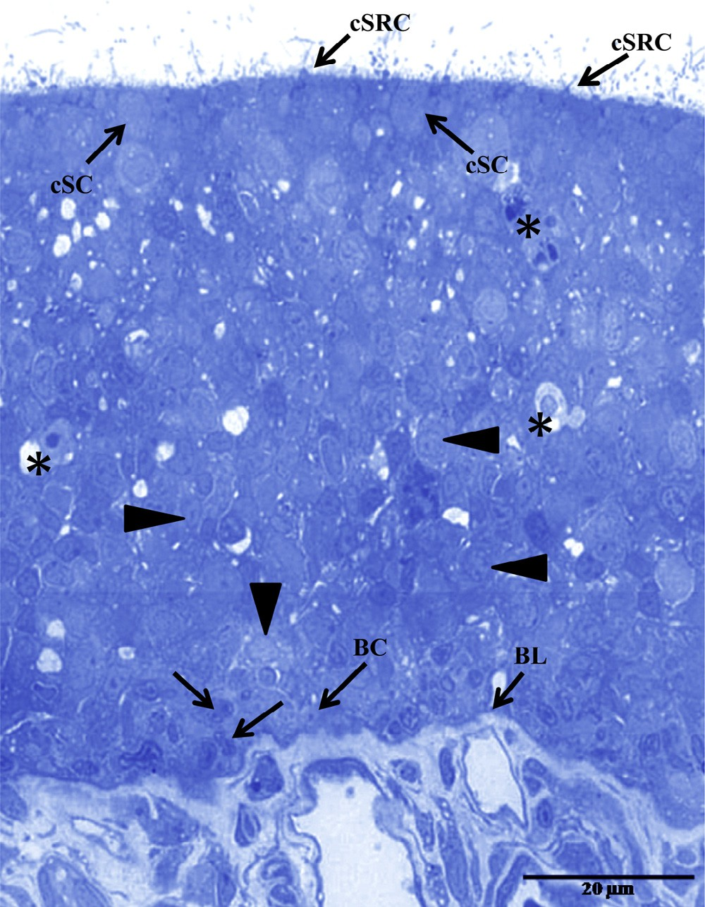

**Fig. 1 – The photomicrograph of a semi-thin histological section shows pseudostratified olfactory neuroepithelium of *P. lanceolatus* that includes various types of cell [ciliated sensory receptor cell (cSRC), supporting cell (cSC), basal cell (BC), *etc.*] resting on the basal lamina (BL). The proliferating basal cells (arrows), differentiating stages (arrow heads) and degenerating stage of sensory receptor cell (stars) are also marked at various depth of olfactory neuroepithelium stained with toluidine blue.**

hours at 4 °C. The frozen sections (thickness: 15–20 µm) were cut by using a cryostat (Leica CM 1850; Leica Biosystems Nussloch GmbH, Germany) and carefully placed on gelatin coated slides. The sections were incubated with Acridine Orange (AO) solu- tion (6 µg/mL) in 0.1 M phosphate buffer (pH 7.3) at 4 °C for 15 minutes to 30 minutes and subsequently washed in the same buffer (3 changes), mounted on glass slides (equal volume of glycerol and buffer is used as mounting medium) and exam- ined under fluorescence microscope [Leica DM 3000; Leica Microsystems] at an excitement of 460 nm to 580 nm. The ac- quired images were analyzed by Microscope Imaging Software [Leica Application Suite Advanced Fluorescence (LAS AF)]. For transmission electron microscopical (TEM) studies, the resin po- lymerized olfactory lamellae of *P. lanceolatus* were cut (thickness:

70 nm–80 nm) by using ultramicrotome (Leica Ultracut – UCT), collected on copper grids and stained with uranyl acetate and lead citrate respectively. The sections were examined under Morgagni 268D transmission electron microscope (Fei Electron Optics, Eindhoven, The Netherlands) operated at 80 kV. Digital images were analyzed at by using iTEM software (soft imaging system, Münster, Germany) attached to the microscope.

# Results

The olfactory apparatus of *P. lanceolatus* is unilamellar in nature and externally lined by pseudostratified neuroepithelium that

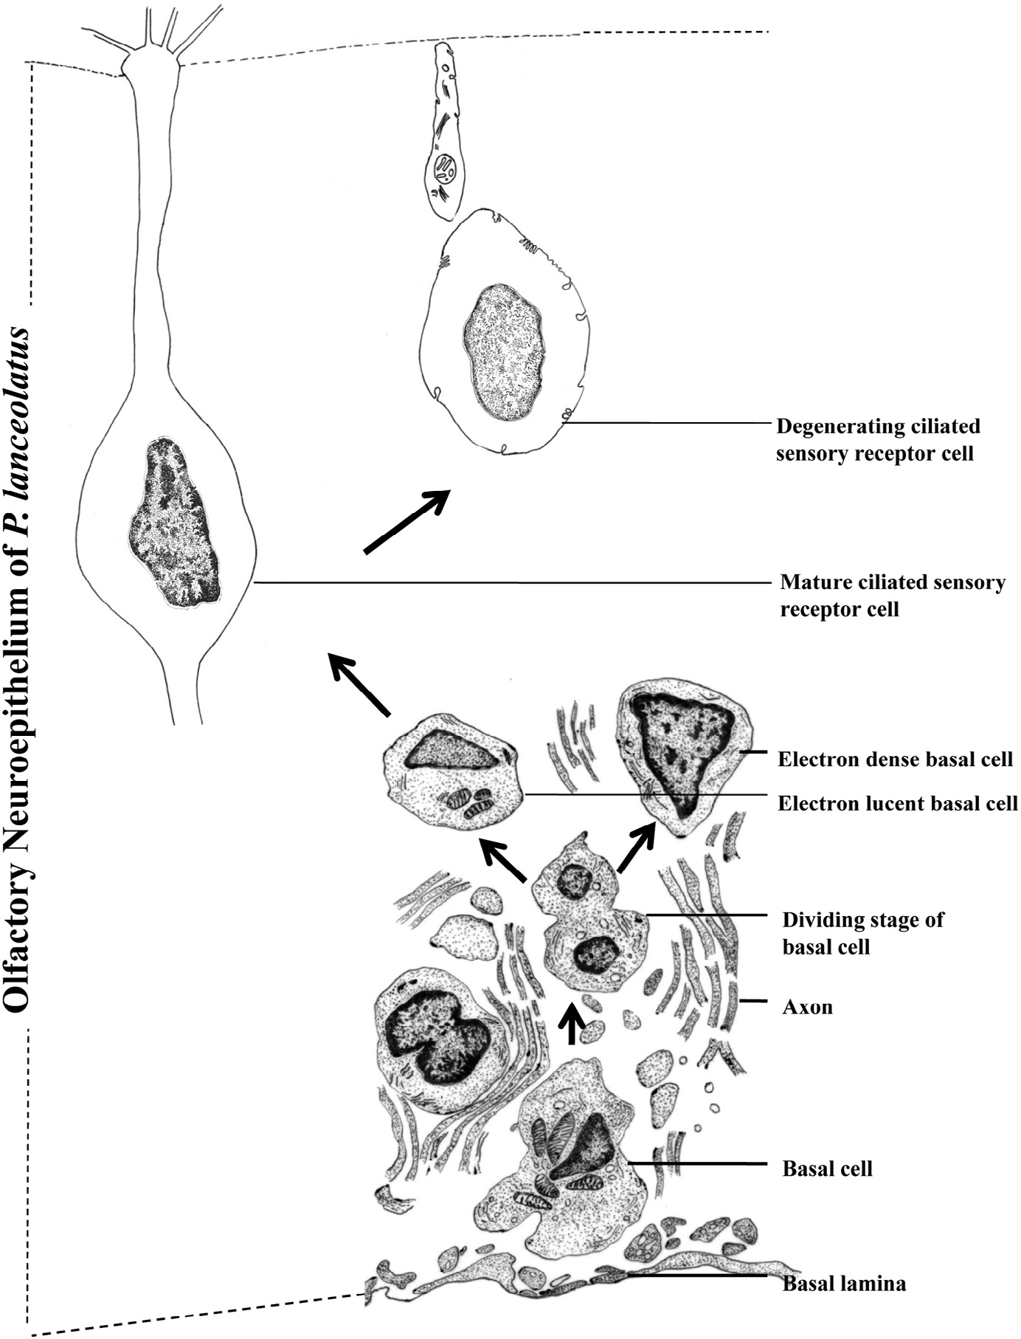

**Fig. 2 – The diagram represents morphological variation in nuclear structures of basal cell, proliferating stages of basal cell, electron lucent and electron dense basal cell, differentiating electron lucent basal cell, mature ciliated sensory receptor cell and degenerating ciliated sensory receptor cell based on transmission electron micrographs of the olfactory neuroepithelium in *Pseudapocryptes lanceolatus* (Bloch and Schneider, 1801).**

**[Not to Scale].**

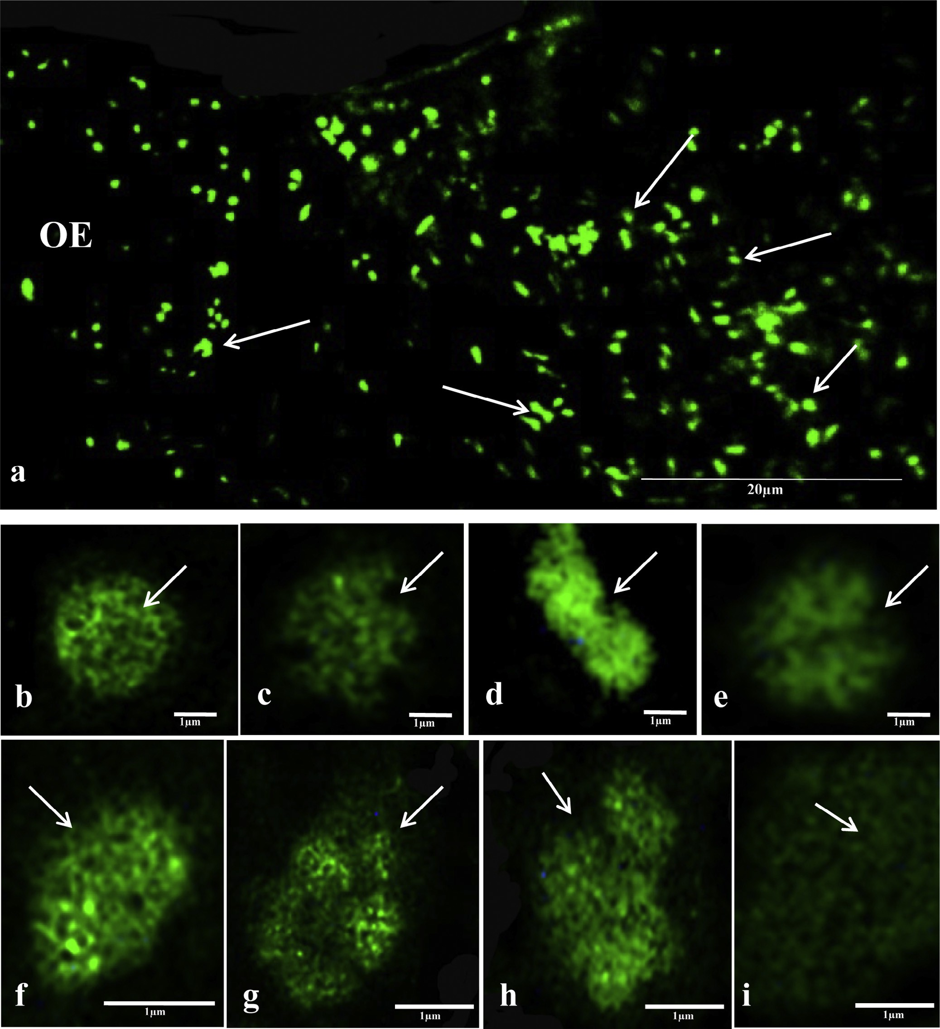

**Fig. 3 – The characteristic variations in nuclear elements of different neuroepithelial components of *P. lanceolatus* are marked under fluorescence microscope. (a) The olfactory neuroepithelium (OE) shows variable morphology of the nucleus at different depths (arrows). (b) The micrograph shows the nucleus of the basal cell (arrow). (c–e) Diverse stages of the nuclear proliferation in basal cell are marked (arrows). (f) The fluorescent micrograph indicates the nucleus of differentiating electron lucent basal cell (arrow). (g, h) The gradual condensation in chromatin fibers within the nucleus of immature and mature ciliated sensory receptor cells is distinctly noted. (i) The degenerating ciliated sensory receptor cell shows loose distribution of fragmented chromatin fibers within the nucleoplasm.**

mainly includes sensory receptor cell, supporting cell and basal cell (Fig. 1). These cellular components are resting on the basal lamina. The ciliated sensory receptor cells are mostly ob- served throughout the olfactory neuroepithelium of *P. lanceolatus* (Fig. 1). The proliferating and differentiating stages of basal cells are sequentially located just above the layer of basal cell in ol- factory neuroepithelium and shows gradual morphological changes in nuclear structure (Figs. 1 and 2). The nuclear ele- ments at different stages of proliferating, differentiating basal cells, mature ciliated sensory receptor cell and degenerating ciliated sensory receptor cells are distinctly noted under fluo- rescence and transmission electron microscope (TEM) respectively. Chromatin fibers with double stranded DNA (dsDNA) are highlighted (green fluorescence) within the nu- cleoplasm of successive stages differentiation (Fig. 3a–i). The qualitative changes in the nuclear elements (*i.e.,* horizontal cleavage of chromatin fibers and condensation pattern of double stranded DNA) are characterized in several stages of proliferating

and differentiating basal cells (Fig. 3b–f). Features of chroma- tin condensation among the mature ciliated sensory receptor cells are also comparable under fluorescence microscope (Fig. 3g, h). The fragmented chromatin fibers are marked within the degenerating ciliated sensory receptor cell (Fig. 3i). The trans- mission electron micrographs show a spherical nucleus in basal cells that possesses large euchromatin materials which are ema- nating from the border of heterochromatin (Fig. 4a). Large clusters of chromatin granules (diameter: 10 nm–20 nm) are ob- served within the nucleoplasm and condensed near the inner nuclear membrane by forming dense heterochromatin mate- rials (Fig. 4a). There are two types of progeny basal cells including electron lucent and electron dense basal cells, iden- tified just above the layer of dividing basal cells (Fig. 4b–d). The differentiating stages of electron lucent basal cell show much variation in their morphology and condensation of chroma- tin materials within the nucleus (Fig. 5). In the early stage of electron lucent basal cell, the nucleus is round in shape and

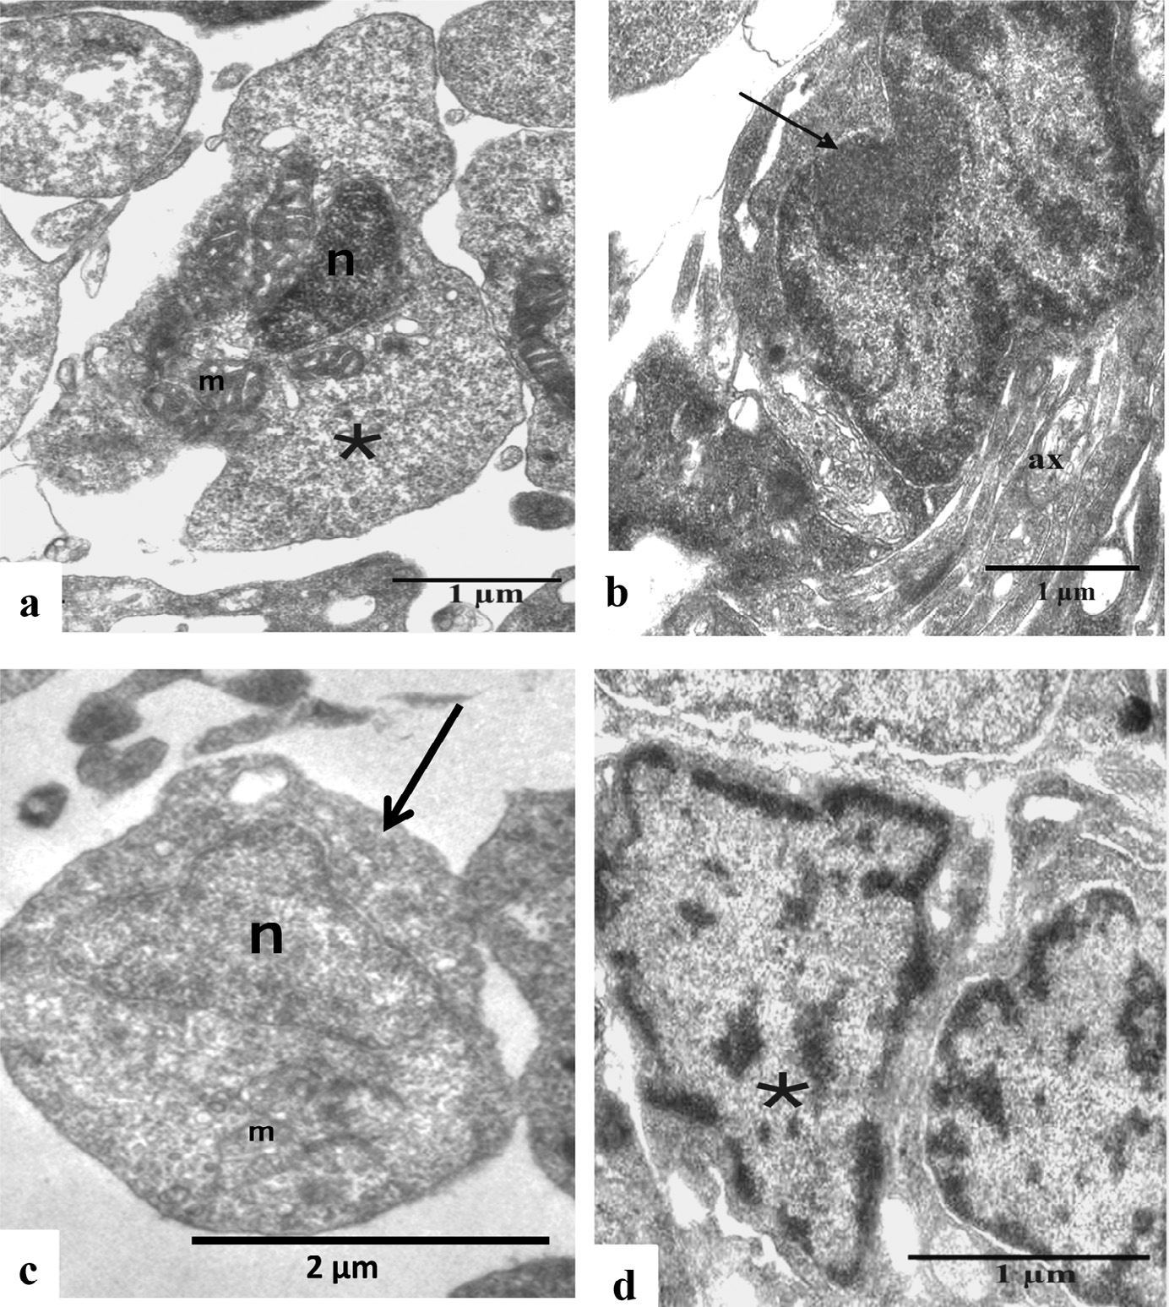

**Fig. 4 – The electron micrograph shows basal cell, dividing basal cell and progeny of basal cell *i.e.,* electron lucent basal cell and electron dense basal cell. (a) The polygonal basal cell (*) with prominent chromatinized nucleus (N), clusters of mitochondria with dense cristae (M), *etc.* is marked. (b) The mitotic stage of the basal cell (**→**) is identified at the basal region of the olfactory neuroepithelium. Several axons (ax) are also noted in this micrograph. (c) The electron lucent basal cell (**→**) possesses euchromatinized nucleus (N) with prominent chromatin granules. Mitochondria (M) are also present at the peri- nuclear cytoplasm. (d) The photomicrograph shows electron dense basal cell (*) with large chromatinized nucleus.**

**Heterochromatin materials are scattered at the peripheral part of the nucleoplasm.**

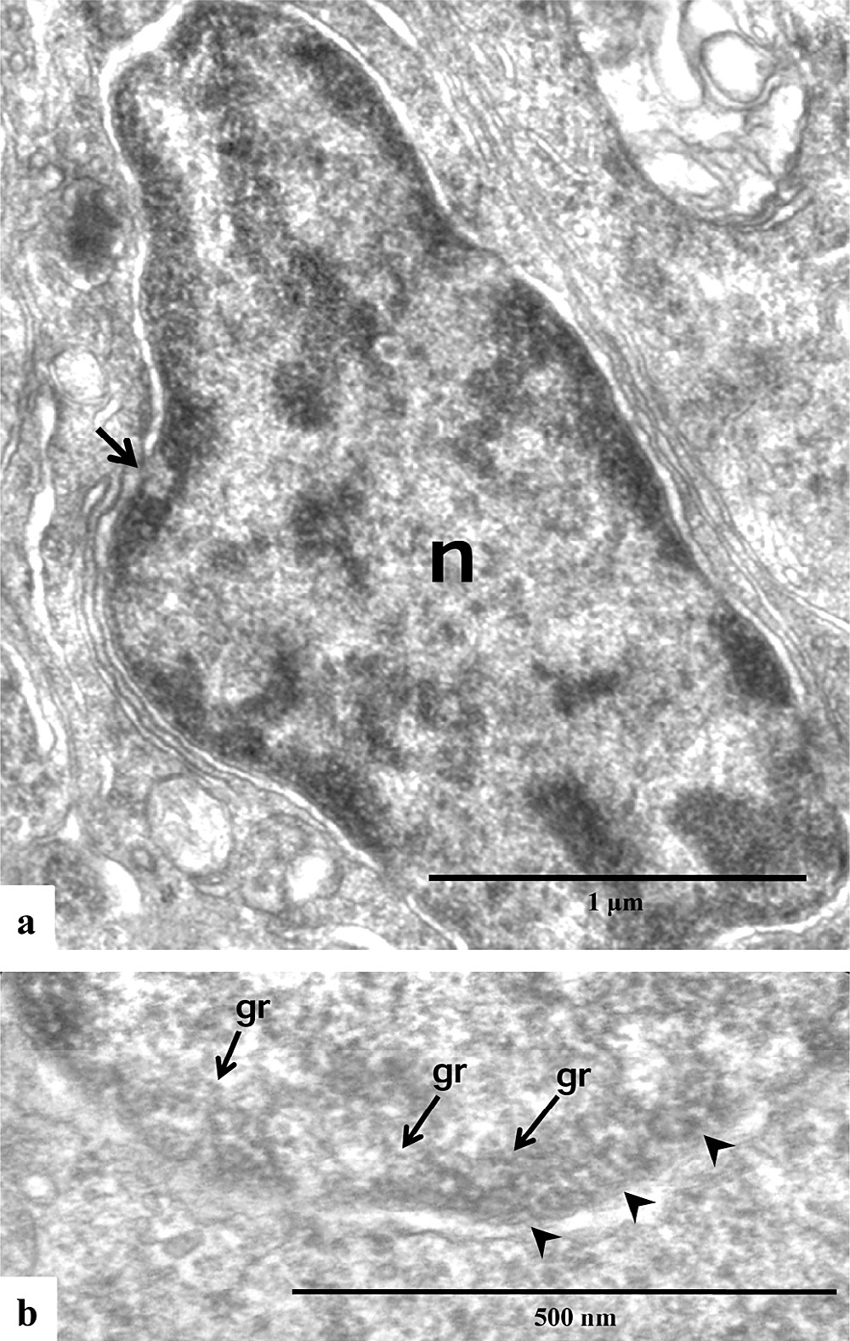

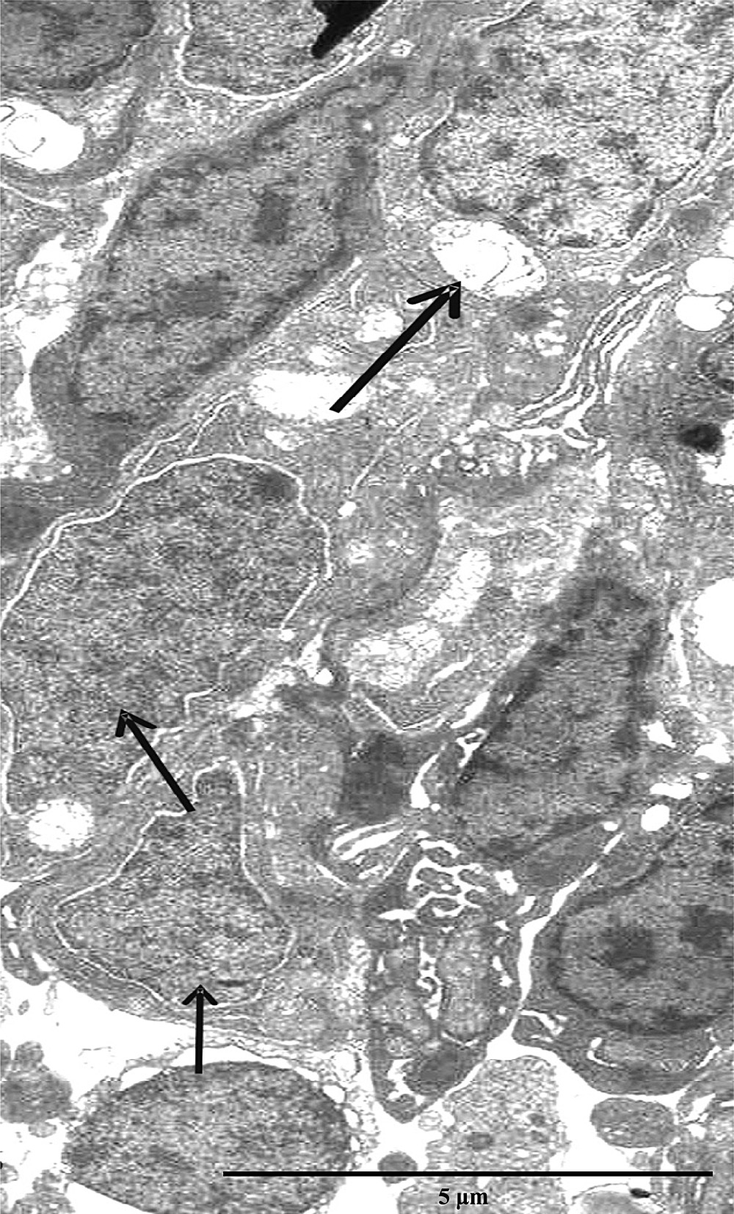**Fig. 5 – The ultrastructural features of gradual morphological changes in differentiating electron lucent basal cell (arrows) and characteristic condensation of chromatin granules within the nucleoplasm are marked under transmission electron microscope (TEM).**

**Fig. 6 – (a) The photomicrograph shows the chromatinized nucleus (n) at the central part of the perikaryon in the sensory receptor cell. The euchromatin and heterochromatin materials are showing distinct distribution pattern within the nucleoplasm. Nucleopore (**→**) is also marked. (b) The condensed chromatin granules (gr) are accumulated near the inner nuclear membrane (arrow heads).**

filled with less condensed, minute fibers of euchromatin ma- terials. Chromatin granules (diameter: 10 nm–20 nm) are uniformly distributed throughout the nucleoplasm. The diam- eter of differentiating electron lucent basal cell is also gradually increased at the various successive stages of differentiation (Fig. 5). The early mature stage of ciliated sensory receptor cell possesses less granulated, chromatinized nucleus at the central part of the perikaryon (Fig. 5). The peripheral part of the nu- cleoplasm in mature ciliated sensory receptor cell shows large accumulation of chromatin granules (diameter: 20 nm–30 nm) (Fig. 6a and b). The degenerating sensory receptor cells are also distinctly marked at the different depths of the adult olfac- tory neuroepithelium of *P. lanceolatus* (Fig. 7a). The perikaryon of degenerating sensory receptor cell is roughly irregular in shape. The plasma membrane shows several blebs, project- ing outwards. The nucleoplasm is less compact and shows fragmented chromatin fibers (Fig. 7b). The chromatin granules

(diameter: 20 nm–30 nm) are comparatively less in number than mature sensory receptor cell and loosely distributed at the ad- jacent area of inner nuclear membrane (Fig. 7c).

# Discussion

The event of neurogenesis in an olfactory chemosensory system significantly differs among the invertebrate and vertebrates due to the variable anatomical organization of their peripheral nervous systems [22]. The cellular proliferation within the ol- factory neuroepithelium is an essential cytological process for the continuous turnover of new olfactory sensory receptor cells that originate from progenitor basal cells throughout the life span of vertebrates [8,23–26]. These cells divide several times

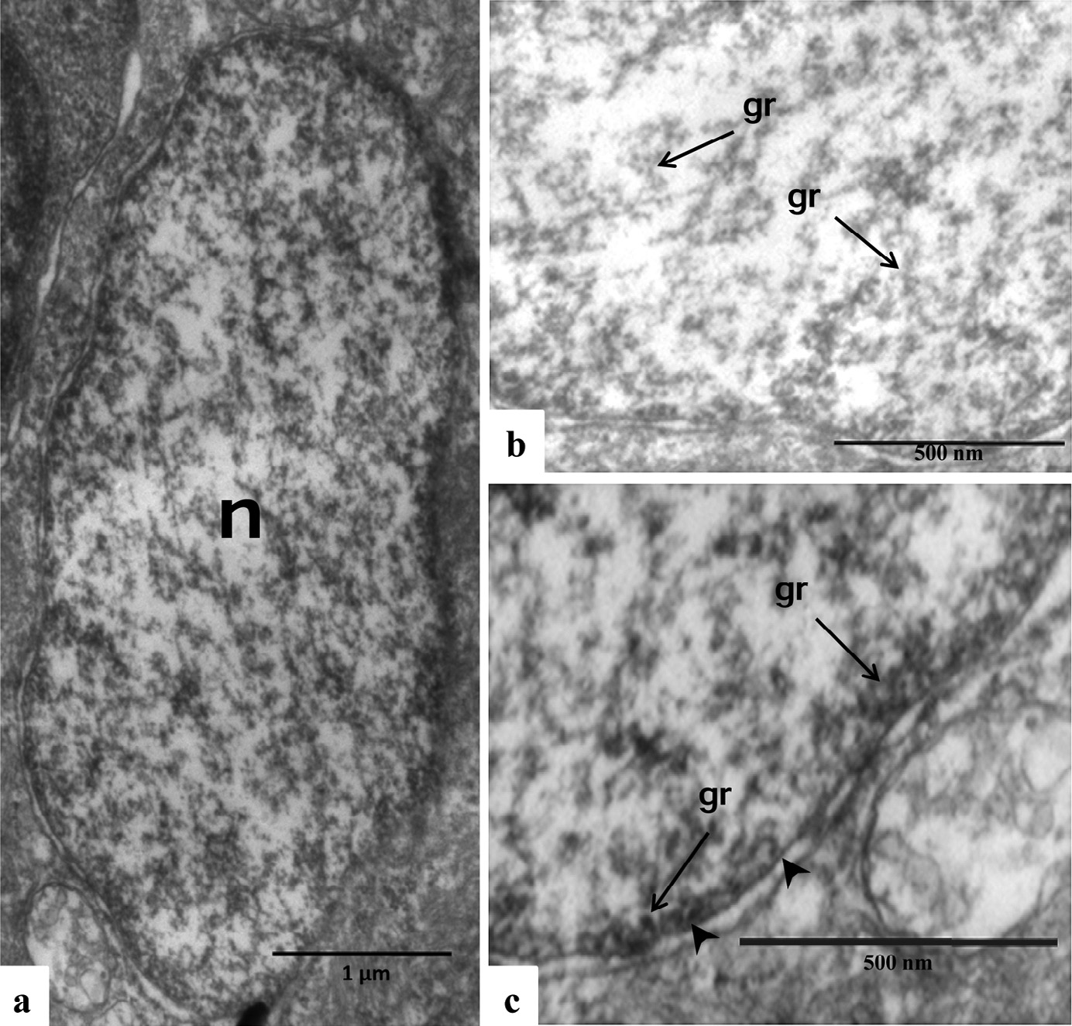

**Fig. 7 – (a) The perikaryon of degenerating sensory receptor cell shows a spherical nucleus (n) with fragmented chromatin materials. (b) The chromatin granules (gr) with fragmented fibers are frequently distributed throughout the nucleoplasm.**

**(c) Accumulation of few chromatin granules (gr) is also marked at the adjacent area of inner nuclear membrane (arrow heads).**

and their progeny differentiate into mature sensory receptor cells [27]. The cell division of progenitors may be followed by specification and differentiation into post mitotic neuron which is regarded as a major cellular event during neurogenesis within the olfactory neuroepithelium [28]. The basal cell is residing at a fixed position near the basal lamina [29] and divides to form an electron lucent and electron dense basal cell within the olfactory neuroepithelium of *P. lanceolatus*. The electron lucent basal cell (*i.e.,* the progeny of basal cell) may differen- tiate and transform into immature olfactory sensory receptor cell. In olfactory neuroepithelium, variation in cellular mor- phology (*i.e.,* polygonal basal cell to egg-shaped perikaryon of sensory receptor cell) and ultrastructural features of chang- ing nuclear structure are the most distinguishing features, noted within the different stages of olfactory sensory receptor neurons in *P. lanceolatus*. Chromatin structure in the interphase cell nucleus is usually organized into ‘repressive’ heterochroma- tin (*i.e.,* silent) domains separated from ‘permissive’ euchromatin (*i.e.,* active) regions of genome which is evident under micro- scopical studies [30]. The distribution of euchromatin at the central and heterochromatin near the inner nuclear envelop indicates an important feature for specific gene expression [31]. The function of heterochromatin formation is multifaceted [32]. This ‘repressed’ chromatin state is important for nuclear pro- cesses such as chromosome condensation during mitosis [33,34].

During differentiation, the chromatin structure shows dramatic variation in the organization of nuclear chromatin structures [35]. The average diameter of first level of chromatin fiber is 10 nm which is subsequently built-up from DNA wrapped around the nucleosomes, folded and condensed by several factors (like protein–DNA and protein–protein interactions in- cluding individual nucleosomes, the linker histone H1 as well as other proteins) into a 30 nm chromatin fiber and higher- ordered chromatin structures [34]. The gradual condensation of chromatin structure in various differentiating stages from electron lucent basal cell to sensory receptor cell probably rep- resents the qualitative maturation as well as aging of the cell [36]. The degenerating sensory receptor cells are also dis- tinctly identified through the presence of fragmented chromatin fibers within the nucleus. Therefore, the condensation of chro- matin materials may be a prime cytological indicator to recognize various stages of cellular differentiation within the olfactory neuroepithelium of *P. lanceolatus*. Finally, inter- and intragenic interaction over a large genomic configuration may be responsible in controlling specific gene expression as well as differentiation of new cellular components [37]. An exten- sive study is under progress to explore genome based molecular aspects of development and differentiation of various olfac- tory sensory receptor cells having different phenotypical expressions (*i.e.,* ciliated sensory receptor cell, microvillus

sensory receptor cell and crypt cell) within the adult olfac- tory neuroepithelium of *P. lanceolatus*.

# Acknowledgements

We are thankful to Prof. R. Chakrabarti, the Hon’ble Vice Chan- cellor, Vidyasagar University, India and Prof. T. Cremer, Ludwig Maximilians University (LMU), Germany for their motivation and necessary advice.

R E F E R E N C E S

1. [Lancet D. Vertebrate olfactory reception. Ann Rev Neurosci](http://refhub.elsevier.com/S2314-808X(15)00046-9/sr0010) [1986;9:329–55.](http://refhub.elsevier.com/S2314-808X(15)00046-9/sr0010)
2. [Buck L, Axel R. A novel multigene family may encode](http://refhub.elsevier.com/S2314-808X(15)00046-9/sr0015) [odorant receptors: a molecular basis for odor recognition.](http://refhub.elsevier.com/S2314-808X(15)00046-9/sr0015) [Cell 1991;65:175–87.](http://refhub.elsevier.com/S2314-808X(15)00046-9/sr0015)
3. [Pifferi S, Menini A, Takashi K. Signal transduction in](http://refhub.elsevier.com/S2314-808X(15)00046-9/sr0020) [vertebrate olfactory cilia. In: Menini A, editor. The](http://refhub.elsevier.com/S2314-808X(15)00046-9/sr0020) [neurobiology of olfaction. Boca Raton, FL: CRC Press; 2010. p.](http://refhub.elsevier.com/S2314-808X(15)00046-9/sr0020) [203–24.](http://refhub.elsevier.com/S2314-808X(15)00046-9/sr0020)
4. [Hansen A, Anderson KT, Finger TE. Differential distribution](http://refhub.elsevier.com/S2314-808X(15)00046-9/sr0025) [of olfactory receptor neurons in goldfish: structural and](http://refhub.elsevier.com/S2314-808X(15)00046-9/sr0025) [molecular correlates. J Comp Neurol 2004;477:347–59.](http://refhub.elsevier.com/S2314-808X(15)00046-9/sr0025)
5. [Hamdani EH, Døving KB. The functional organization of the](http://refhub.elsevier.com/S2314-808X(15)00046-9/sr0030) [fish olfactory system. Prog Neurobiol 2007;82:80–6.](http://refhub.elsevier.com/S2314-808X(15)00046-9/sr0030)
6. [Farbman AI. Cell biology of olfaction. England: Cambridge](http://refhub.elsevier.com/S2314-808X(15)00046-9/sr0035) [University Press; 1992.](http://refhub.elsevier.com/S2314-808X(15)00046-9/sr0035)
7. [Eisthen HL. Why are olfactory systems of different animals](http://refhub.elsevier.com/S2314-808X(15)00046-9/sr0040) [so similar? Brain Behav Evol 2002;59:273–93.](http://refhub.elsevier.com/S2314-808X(15)00046-9/sr0040)
8. [Graziadei PPC, Monti Graziadei GA. Continuous nerve cell](http://refhub.elsevier.com/S2314-808X(15)00046-9/sr0045) [renewal in the olfactory system. In: Jacobson M, editor.](http://refhub.elsevier.com/S2314-808X(15)00046-9/sr0045) [Handbook of sensory physiology, vol. 9. New York: Springer-](http://refhub.elsevier.com/S2314-808X(15)00046-9/sr0045) [Verlag; 1978. p. 55–83.](http://refhub.elsevier.com/S2314-808X(15)00046-9/sr0045)
9. [Farbman AI. Olfactory neurogenesis: genetic or](http://refhub.elsevier.com/S2314-808X(15)00046-9/sr0050) [environmental control. Trends Neurosci 1990;13:362–5.](http://refhub.elsevier.com/S2314-808X(15)00046-9/sr0050)
10. [Thiemmara V, Pays L, Danty E, Jourdan F, Moyse E, Mehlen P.](http://refhub.elsevier.com/S2314-808X(15)00046-9/sr0055) [Serine protease inhibitor Spi2 mediated apoptosis of](http://refhub.elsevier.com/S2314-808X(15)00046-9/sr0055) [olfactory neurons. Cell Death & Different 2002;9:1343–51.](http://refhub.elsevier.com/S2314-808X(15)00046-9/sr0055)
11. [Gokoffski KK, Kawauchi S, Wu HH, Santos R, Hollenbeck](http://refhub.elsevier.com/S2314-808X(15)00046-9/sr0060) [PLW, Lander AD, et al. Feedback regulation of neurogenesis](http://refhub.elsevier.com/S2314-808X(15)00046-9/sr0060) [in the mammalian olfactory epithelium: new insights from](http://refhub.elsevier.com/S2314-808X(15)00046-9/sr0060) [genetics and systems biology. In: Menini A, editor. The](http://refhub.elsevier.com/S2314-808X(15)00046-9/sr0060) [neurobiology of olfaction. Boca Raton, FL: CRC Press; 2010. p.](http://refhub.elsevier.com/S2314-808X(15)00046-9/sr0060) [241–66.](http://refhub.elsevier.com/S2314-808X(15)00046-9/sr0060)
12. [Paschaki M, Cammas L, Muta Y, Matsuoka Y, Mak S,](http://refhub.elsevier.com/S2314-808X(15)00046-9/sr0065) [Rataj-Baniowska M. Retinoic acid regulates olfactory](http://refhub.elsevier.com/S2314-808X(15)00046-9/sr0065) [progenitor cell fate and differentiation. Neural Develop](http://refhub.elsevier.com/S2314-808X(15)00046-9/sr0065) [2013;8:13.](http://refhub.elsevier.com/S2314-808X(15)00046-9/sr0065)
13. [Mackay-Sim A, Kittel PW. On the life span of olfactory](http://refhub.elsevier.com/S2314-808X(15)00046-9/sr0070) [receptor neurons. Euro J Neurosci 1991;3:209–15.](http://refhub.elsevier.com/S2314-808X(15)00046-9/sr0070)
14. [Sulz L, Bacigalupo J. Role of nitric oxide during neurogenesis](http://refhub.elsevier.com/S2314-808X(15)00046-9/sr0075) [in the olfactory epithelium. Biol Res 2006;39:589–99.](http://refhub.elsevier.com/S2314-808X(15)00046-9/sr0075)
15. [Armelin-Correa LM, Gutiyama LM, Brandt DY, Malnic B.](http://refhub.elsevier.com/S2314-808X(15)00046-9/sr0080) [Nuclear compartmentalization of odorant receptor genes.](http://refhub.elsevier.com/S2314-808X(15)00046-9/sr0080) [Proc Natl Acad Sci USA 2014;111(7):2782–7.](http://refhub.elsevier.com/S2314-808X(15)00046-9/sr0080)
16. [Magrassi L, Graziadei PP. Cell death in the olfactory](http://refhub.elsevier.com/S2314-808X(15)00046-9/sr0085) [epithelium. Anat Embryol (Berl) 1995;192(1):77–87.](http://refhub.elsevier.com/S2314-808X(15)00046-9/sr0085)
17. [Nicolay DJ, Doucette JR, Nazarali AJ. Transcriptional](http://refhub.elsevier.com/S2314-808X(15)00046-9/sr0090) [regulation of neurogenesis in the olfactory epithelium. Cell](http://refhub.elsevier.com/S2314-808X(15)00046-9/sr0090) [Mol Neurobiol 2006;26:801–19.](http://refhub.elsevier.com/S2314-808X(15)00046-9/sr0090)
18. [De SK, Sarkar SK. Macroanatomy and ultrastructural studies](http://refhub.elsevier.com/S2314-808X(15)00046-9/sr0095) [on olfactory sensory epithelial components of](http://refhub.elsevier.com/S2314-808X(15)00046-9/sr0095) [*Pseudapocryptes lanceolatus* (Bloch and Schneider). The 20th](http://refhub.elsevier.com/S2314-808X(15)00046-9/sr0095) [Congress of the European Chemoreception Research](http://refhub.elsevier.com/S2314-808X(15)00046-9/sr0095) [Organization (ECRO), Avignon, France, September 14–19,](http://refhub.elsevier.com/S2314-808X(15)00046-9/sr0095) [2010. pp. 160.](http://refhub.elsevier.com/S2314-808X(15)00046-9/sr0095)
19. [Sarkar SK, De SK. A study on olfactory neuroepithelium of](http://refhub.elsevier.com/S2314-808X(15)00046-9/sr0100) [*Pseudapocryptes lanceolatus* (Bloch and Schneider): medical](http://refhub.elsevier.com/S2314-808X(15)00046-9/sr0100) [analog x-ray based anatomy and transmission electron](http://refhub.elsevier.com/S2314-808X(15)00046-9/sr0100) [microscopical interpretations. Int J Sci Nat 2011;2(2):186–91.](http://refhub.elsevier.com/S2314-808X(15)00046-9/sr0100)
20. [Sarkar SK, Acharya A, Jana S, De SK. Macroanatomical](http://refhub.elsevier.com/S2314-808X(15)00046-9/sr0105) [variation of the olfactory apparatus in some Indian teleosts](http://refhub.elsevier.com/S2314-808X(15)00046-9/sr0105) [with special reference to their ecological habitat. Folia](http://refhub.elsevier.com/S2314-808X(15)00046-9/sr0105) [Morphol (Warsz) 2014;73(2):122–8.](http://refhub.elsevier.com/S2314-808X(15)00046-9/sr0105)
21. [Sarkar SK, Jana S, De SK. Age-specific anatomy and](http://refhub.elsevier.com/S2314-808X(15)00046-9/sr0110) [cytological studies on unilamellar olfactory structure of a](http://refhub.elsevier.com/S2314-808X(15)00046-9/sr0110) [teleost (*Pseudapocryptes lanceolatus*). Euro J Exp Biol](http://refhub.elsevier.com/S2314-808X(15)00046-9/sr0110) [2014;4(6):105–11.](http://refhub.elsevier.com/S2314-808X(15)00046-9/sr0110)
22. [Salzberg A, Bellen HJ. Invertebrate versus vertebrate](http://refhub.elsevier.com/S2314-808X(15)00046-9/sr0115) [neurogenesis: variation on the same theme? Dev Gen](http://refhub.elsevier.com/S2314-808X(15)00046-9/sr0115) [1996;18:1–10.](http://refhub.elsevier.com/S2314-808X(15)00046-9/sr0115)
23. [Schwartz LM, Chikaraishi DM, Kauer JS. Characterization of](http://refhub.elsevier.com/S2314-808X(15)00046-9/sr0120) [potential precursor populations in the mouse olfactory](http://refhub.elsevier.com/S2314-808X(15)00046-9/sr0120) [epithelium using immunocytochemistry and](http://refhub.elsevier.com/S2314-808X(15)00046-9/sr0120) [autoradiography. J Neurosci 1991;11:3556–64.](http://refhub.elsevier.com/S2314-808X(15)00046-9/sr0120)
24. [Caggiano M, Kauer JS, Hunter DD. Globose basal cells are](http://refhub.elsevier.com/S2314-808X(15)00046-9/sr0125) [neuronal progenitors in the olfactory epithelium: a lineage](http://refhub.elsevier.com/S2314-808X(15)00046-9/sr0125) [analysis using a replication-incompetent retrovirus. Neuron](http://refhub.elsevier.com/S2314-808X(15)00046-9/sr0125) [1994;13:339–52.](http://refhub.elsevier.com/S2314-808X(15)00046-9/sr0125)
25. [Sarkar SK, De SK. Ultrastructural study on the olfactory](http://refhub.elsevier.com/S2314-808X(15)00046-9/sr0130) [progenitor cells of *Pseudapocryptes lanceolatus* (Bloch and](http://refhub.elsevier.com/S2314-808X(15)00046-9/sr0130) [Schneider). Regen Med 2009;4:S272–3.](http://refhub.elsevier.com/S2314-808X(15)00046-9/sr0130)
26. [Brann JH, Firestein SJ. A lifetime neurogenesis in the](http://refhub.elsevier.com/S2314-808X(15)00046-9/sr0135) [olfactory system. Front Neurosci 2014;8:182.](http://refhub.elsevier.com/S2314-808X(15)00046-9/sr0135)
27. [Hsu Y, Fuchs E. A family business: stem cell progeny join the](http://refhub.elsevier.com/S2314-808X(15)00046-9/sr0140) [niche to regulate homeostasis. Nat Rev Mol Cell Biol](http://refhub.elsevier.com/S2314-808X(15)00046-9/sr0140) [2012;13:103–14.](http://refhub.elsevier.com/S2314-808X(15)00046-9/sr0140)
28. [Schmidt F, Göktas Ö, Jarius S, Wildemann B, Ruprecht K,](http://refhub.elsevier.com/S2314-808X(15)00046-9/sr0145) [Paul F. Olfactory dysfunction in patients with neuromyelitis](http://refhub.elsevier.com/S2314-808X(15)00046-9/sr0145) [optica. Multiple Scler Int 2013;2013:1–4.](http://refhub.elsevier.com/S2314-808X(15)00046-9/sr0145)
29. [Mackay-Sim A. Stem cell and their niche in the adult](http://refhub.elsevier.com/S2314-808X(15)00046-9/sr0150) [olfactory mucosa. Arch Ital de Biologie 2010;148:47–58.](http://refhub.elsevier.com/S2314-808X(15)00046-9/sr0150)
30. [Guelen L, Pagie L, Brasset E, Meuleman W, Faza MB,](http://refhub.elsevier.com/S2314-808X(15)00046-9/sr0155)

[Talhout W. Domain organization of human chromosomes](http://refhub.elsevier.com/S2314-808X(15)00046-9/sr0155) [revealed by mapping of nuclear lamina interactions. Nature](http://refhub.elsevier.com/S2314-808X(15)00046-9/sr0155) [2008;453:948–51.](http://refhub.elsevier.com/S2314-808X(15)00046-9/sr0155)

1. [Peric-Hupkes D, van Steensel B. Role of the nuclear lamina](http://refhub.elsevier.com/S2314-808X(15)00046-9/sr0160) [in genome organization and gene expression. Cold Spring](http://refhub.elsevier.com/S2314-808X(15)00046-9/sr0160) [Harb Symp Quant Biol 2010;75:517–24.](http://refhub.elsevier.com/S2314-808X(15)00046-9/sr0160)
2. [Martin C, Zhang Y. The diverse functions of histone lysine](http://refhub.elsevier.com/S2314-808X(15)00046-9/sr0165) [methylation. Nat Rev Mol Cell Biol 2005;6:838–49.](http://refhub.elsevier.com/S2314-808X(15)00046-9/sr0165)
3. [Grewal SI, Rice JC. Regulation of heterochromatin by histone](http://refhub.elsevier.com/S2314-808X(15)00046-9/sr0170) [methylation and small RNAs. Curr Opin Cell Biol](http://refhub.elsevier.com/S2314-808X(15)00046-9/sr0170) [2004;16:230–8.](http://refhub.elsevier.com/S2314-808X(15)00046-9/sr0170)
4. [Postberg J, Heyse K, Cremer M, Cremer T, Lipps HJ. Spatial](http://refhub.elsevier.com/S2314-808X(15)00046-9/sr0175) [and temporal plasticity of chromatin during programmed](http://refhub.elsevier.com/S2314-808X(15)00046-9/sr0175) [DNA-reorganization in Stylonychia macronuclear](http://refhub.elsevier.com/S2314-808X(15)00046-9/sr0175) [development. Epigen Chromatin 2008;1:3.](http://refhub.elsevier.com/S2314-808X(15)00046-9/sr0175)
5. [Solovei I, Kreysing M, Lanctot C, Kosem S, Peichl L, Cremer T.](http://refhub.elsevier.com/S2314-808X(15)00046-9/sr0180) [Nuclear architecture of rod photoreceptor cells adapts to](http://refhub.elsevier.com/S2314-808X(15)00046-9/sr0180) [vision in mammalian evolution. Cell 2009;137:356–68.](http://refhub.elsevier.com/S2314-808X(15)00046-9/sr0180)
6. [Franziska AO, Hochegger K, Frsehl G, Tiefenbacher R, Pavelka](http://refhub.elsevier.com/S2314-808X(15)00046-9/sr0185)

[M. Condensation during apoptosis is accompanied by](http://refhub.elsevier.com/S2314-808X(15)00046-9/sr0185) [degradation of lamin A +B, without enhanced activation of](http://refhub.elsevier.com/S2314-808X(15)00046-9/sr0185) [cdc2 kinase. J Cell Biol 1994;126:827–37.](http://refhub.elsevier.com/S2314-808X(15)00046-9/sr0185)

1. [de Wit E, de Laat W. A decade of 3C technologies: insights](http://refhub.elsevier.com/S2314-808X(15)00046-9/sr0190) [into nuclear organization. Genes Dev 2012;26:11–24.](http://refhub.elsevier.com/S2314-808X(15)00046-9/sr0190)